# **END – SEMESTER LAB EXAM**

Register Number: 1740256

**Date:** 12/03/2018

--------------------------------------------------------------------------------------------

**Question 1**

**Aim:**

Use the SPSS file sleep.sav and make atleast 3 different graphs.

**Procedure:**

1. Open SPSS and let the sleep.sav file appear in SPSS.
2. Click on the Graphs button and a drop-down button appears.
3. In the drop down button click on chart builder.
4. Click ok on the dialogue box.
5. Drag and drop the desired type of graph in the above empty space.
6. We observe the graph is displayed in the top portion
7. Choose any 2 variables – 1 for x-axis and one for y-axis to plot the graph.
8. Then click on ok and the graph appears in the output.

**Calculations:**

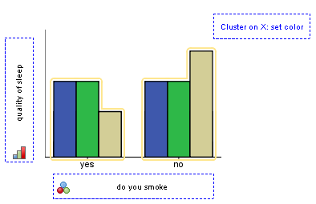 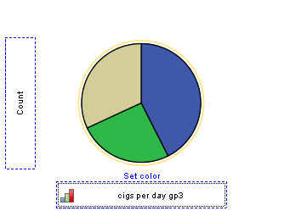

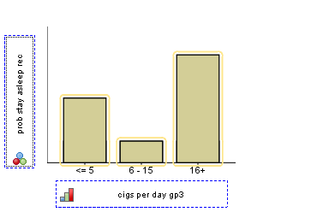

**Conclusions:**

The above 3 graphs show a bar chart, a pie chart & a histogram respectively. It is made with respecting to the probability they smoke or stay asleep given the number of cigarettes they take per day.

--------------------------------------------------------------------------------------------------------------------------------------

**Question 2**

**Aim:**

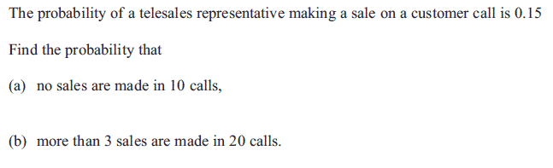

**Procedure:**

1. Open an excel sheet and choose an empty cell.
2. To compute binomial probabilities, we use =binom.dist (x, n, p, cumulative)
3. Cumulative denotes a cumulative distribution function if it is put as true and denotes the probability mass function if it is put as false.

**Calculations:**

1. 



1. More than 3 = 1 – P(X<=2)





**Conclusions:**

The above calculations are done using Excel in calculating the binomial distribution for the given question.

--------------------------------------------------------------------------------------------------------------------------------------

**Question 3**

**Aim:** 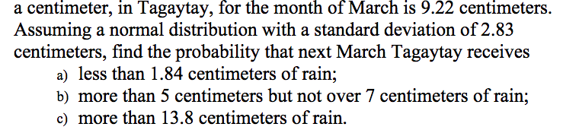

**Procedure:**

1. Open an Excel sheet and type in any empty cell =NORMDIST(x,mean,s.d,cumulative).
2. Type the value of mean and standard deviation as given in the question and type true if we require cumulative values, otherwise type false.

**Calculations:**

Mean = 9.22 Standard Deviation = 2.83

1.  

1.  

1.  

**Conclusions:**

The above calculations show the normal distribution answers using Excel for the above questions.

--------------------------------------------------------------------------------------------------------------------------------------



